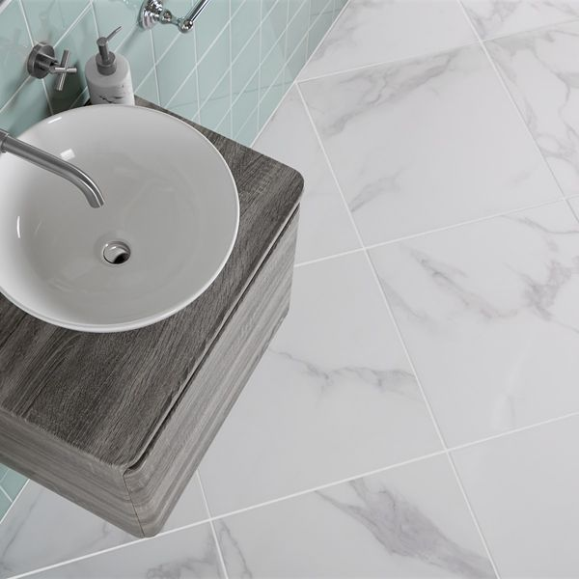**Ruscello White Gloss 60x60 Tiles:**

## **Product Description**

These Ruscello Marble Effect Tiles are perfect for creating a natural, opulent look in your home. Inspired by Italy’s famous Calacatta Marble Tiles, they have a stunning marble effect design with delicate grey veins. Made from durable porcelain, they have a shimmering gloss finish that reflects the light for a space-enhancing look.

**What's special about these tiles?**

> Luxurious marble effect design  
> Shimmering gloss finish  
> Organic veining for soft, elegant style  
> Durable, hardwearing porcelain body  
> Perfect for an opulent feel on flooring or walls

## **Product Info**

* Product ID: 44900
* Tiles Per SQM: 2.7777777777778
* Sale by: Per SQM
* Size: 600x600x9.5mm
* Weight: 6.73 KG
* Material Type: Porcelain
* Finish: Gloss
* Colour: White
* Suitability: Floors, Walls
* Grade: 4
* Rectified Edge: No
* Underfloor Heating: Yes
* Thickness (mm): 9.5